HALLOWEEN EVENT PLANNING DASHBOARD

AIM:
This Dashboard explains the evaluation of the individuals who participate in Halloween activities. It is used to understand the event planning. The following information we can get from this dashboard.

- Find the precipitation level

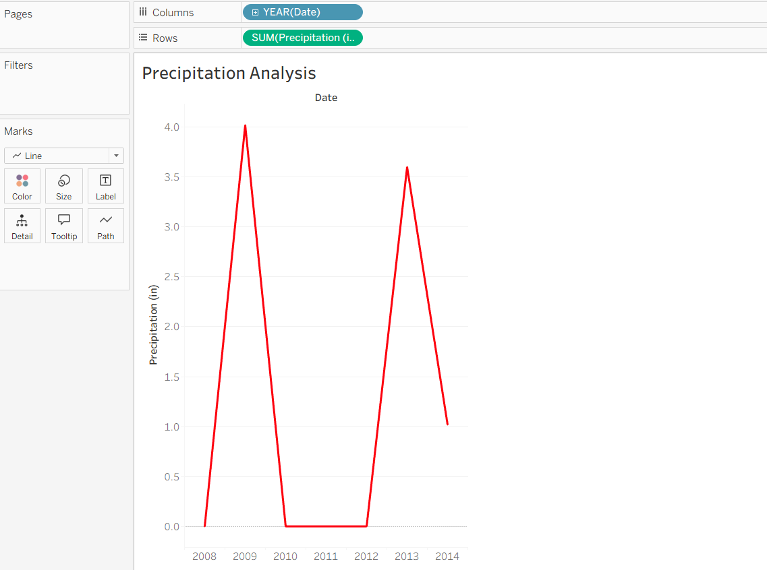

- Show year by year variation

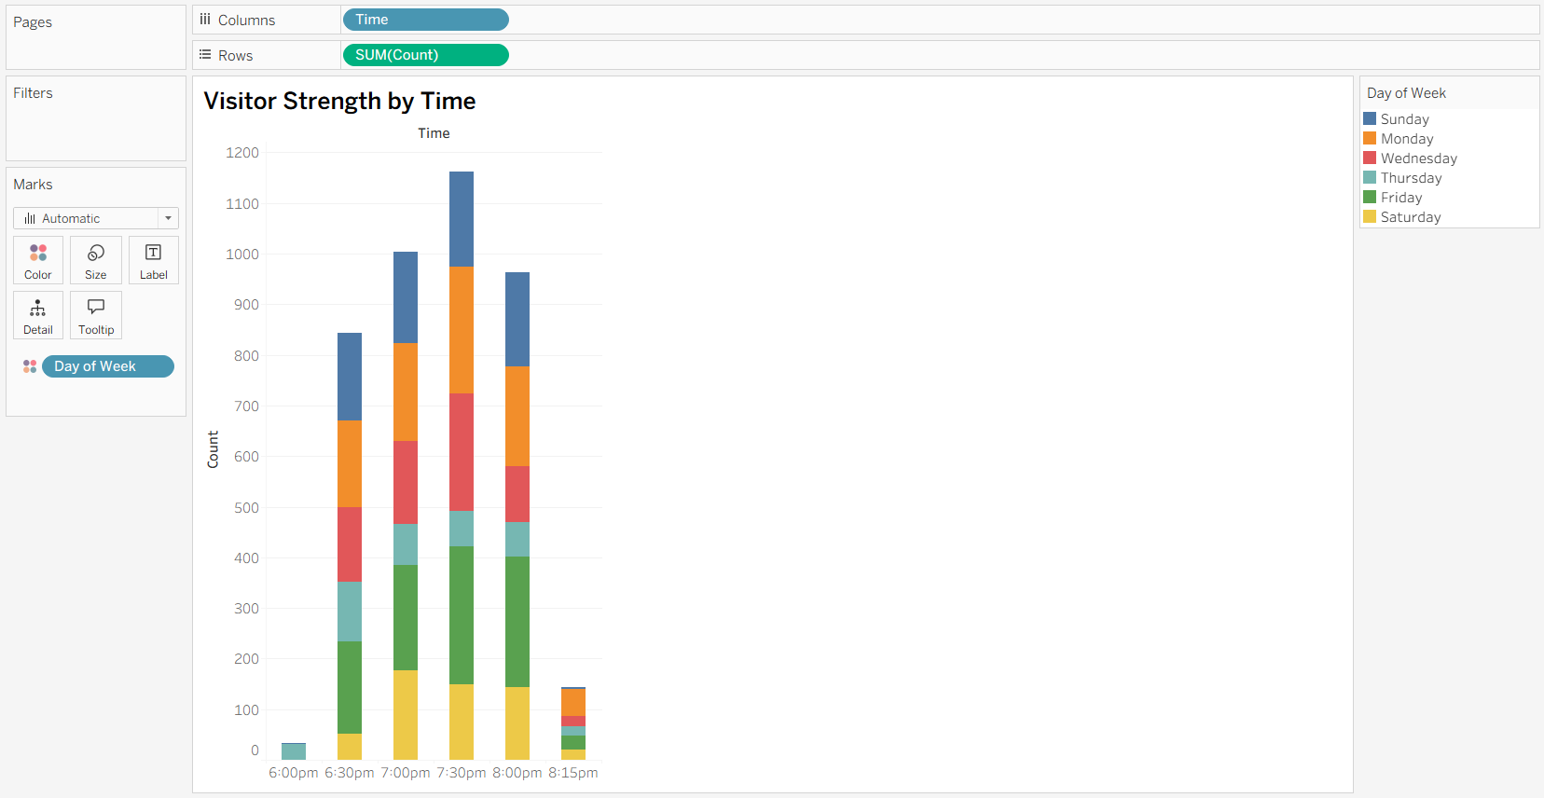

- Forecast the future event
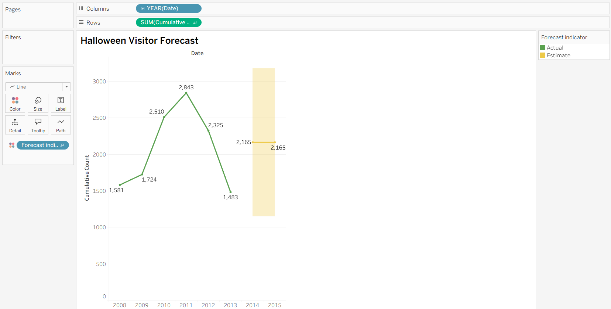

- Display visitor strength

- Show year by year variation



